EcoMovie 2016 with the Friends of Cabin John Creek!
Sunday, February 21
4 - 6 pm

Water Blues Green Solutions
Clara Barton Community Center
7425 MacArthur Blvd Cabin John MD, 20818

Please join us at the screening of the inspirational documentary Water Blues Green Solutions, a 60-minute documentary that explores the nexus of Stormwater Management and Green Design in a variety of settings. “Water Blues is going to help create awareness that we as human beings actually have the ability to contribute to the health of a place,” says Tom Keiter, executive producer of the film. Narrated by Peabody Award winner and MacArthur Fellow Majora Carter, this documentary focuses on how cities like Philadelphia, Portland, San Antonio, and the Bronx are using natural systems to clean, absorb, and help manage water.

A discussion of how the issues and solutions apply to the Cabin John Creek, Potomac River, and Chesapeake Bay watersheds will follow.

FREE ADMISSION!
FREE REFRESHMENTS!

RSVP/Questions: tina@cabinjohncreek.org

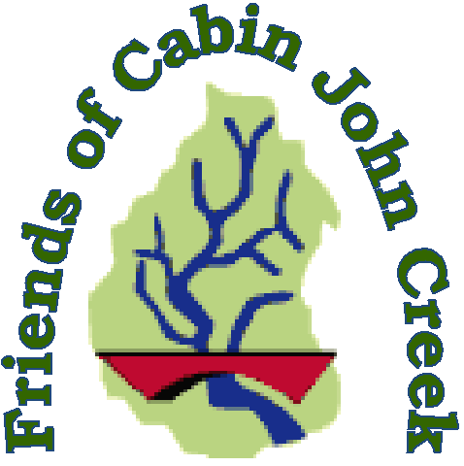

www.cabinjohncreek.org

